**LCA Estimate Model for CCU**

**Beta 0.1**

**Technical Documentation**

Authors

**Emily Nishikawa**, PhD student, Department of Chemical and Petroleum Engineering, University of Calgary

**Shah Ahmad**, PhD Candidate, Agricultural Life and Environmental Sciences, University of Alberta

**Dr. Adriana Gaona Gomez**, Postdoc, Department of Civil & Mineral Engineering, University of Toronto

**Dr. Sylvia Sleep**, Postdoc, Department of Chemical and Petroleum Engineering, University of Calgary

**Dr. Heather McLean**, Associate Professor, Department of Civil & Mineral Engineering, University of Toronto

**Dr. John Wolodko**, Associate Professor, Agricultural Life and Environmental Sciences, University of Alberta

**Dr. Sean McCoy**, Assistant Professor, Department of Chemical and Petroleum Engineering, University of Calgary

**Dr. Joule A. Bergerson**, Associate Professor, Department of Chemical and Petroleum Engineering, University of Calgary

March 2020

Contents

Part I: Introduction and User Guide 5

1 Quick Guide for Working with the Model 5

1.1 Technical Requirements 5

1.2 How to Run the Model 5

1.3 Model Characterization Scheme 5

2 Introduction 7

2.1 Model Motivation and Goals 7

2.2 Model Construction 8

2.2.1 Software System 8

2.2.2 Organization 8

2.2.3 Colour Coding 8

2.2.4 Modelling Approach 8

2.3 Caution when Interpreting Results 9

2.4 Terms of Use 10

3 Guide to the User Interface 10

3.1 Main Input & Output 10

3.1.1 Main Input: General Assumptions 11

3.1.2 Main Input: Example Pathway 12

3.1.3 Results Dashboard: Emissions per kg CO2 Converted 12

3.1.4 Results Dashboard: Emissions per kg of Product 13

3.1.5 Results Dashboard: Avoided Emissions 14

3.1.6 Results Dashboard: Emissions Reduction Potential 15

3.2 Summary Table 15

3.3 Individual Pathways 16

3.4 Incumbents 17

3.5 Energy & Unit Conversions 17

3.6 Constants 17

3.7 Process Correlations 17

3.8 Emission Factors 18

Part II: Technical Documentation 19

4 Reference Studies 19

5 Pathway: CO2 Mineralization 23

6 Pathway: CO2 Reduction Involving Electricity 23

7 Pathway: CO2 Reduction by a Hydrocarbon 26

8 Pathway: CO2 Reduction by Hydrogen 28

9 Pathway: CO2 Reduction Involving Light 29

10 Incumbent Technologies 31

Additional References 34

List of Figures

Figure 1. Process diagram showing the system boundary and main flows into and out of the model. 9

Figure 2. General Assumptions input box 11

Figure 3. Example inputs box for the CO2 Mineralization pathway. 12

Figure 4. Example results: emissions per kg of CO2 converted. 13

Figure 5. Example results: emissions per kg of product 14

Figure 6. Example results: avoided emissions. 14

Figure 7. Example results: global emissions reduction potential. 15

Figure 8: Example of individual pathway tab. 16

Figure 9: Areas of calculation in each individual pathway tab. Calculation boxes (red) are numbered one through five. 16

Figure 10: The Incumbents worksheet. 17

Figure 11: The Emission Factors worksheet. 18

List of Tables

Table 1. CCU categorization scheme 6

Table 2: References for emission factors employed in the model. 18

Table 3: Calculated results on per tonne methanol produced basis. 26

Table 4: Calculated results on per tonne methanol produced basis. 27

Table 5: Calculated results per kg methane produced. 29

Table 6: Calculated emissions of additional inputs on per kg methane produced basis. 30

Table 7: Assumptions for diesel production. 31

Table 8: Calculated requirements for diesel production. 31

Table 9: Assumptions for methane production 33

Table 10: Requirements for methane production. 33

Table 11: Requirements for methanol production. 33

**Acknowledgements**

The authors would like to thank PRIME coalition for the feedback, financial support and helpful suggestions from James DeCunzo and Johanna Wolfson. The authors are also grateful for the contributions from MuhammadYousuf Jabbar and Dr. Liang Jing, from the Department of Chemical and Petroleum Engineering, University of Calgary.

**Terminology and Acronyms**

|  |  |
| --- | --- |
| Acronyms and abbreviations | Description |
| CCU | Carbon Capture and Utilization |
| GHG | Greenhouse Gases |
| LCA | Life Cycle Assessment |
| DAC | Direct Air Capture (CO2) |
| DMC-O | Direct Mineral Carbonation with Olivine |
| DMC-W | Direct Mineral Carbonation with Wollastonite |
| WMC | Waste Mineral Carbonation |
| CWM | Carbonated Waste Materials |
| SOEC-CO | Solid Oxide Electrolyser Cell Co-Electrolysis |
| SOEC-EL | Solid Oxide Electrolyser Cell Electrolysis |
| DMR-CO | Dry Methane Reforming with CO Purging |
| DMR-H2 | Dry Methane Reforming with H2 |
| D-H2 | Direct Hydrogenation to produce fuels |
| P.CAT | Photocatalytic Reduction of CO2 using semiconductors |
| P-DE | Photobioreactor Dry-Extraction |
| P-WE | Pond Wet Extraction |

# Part I: Introduction and User Guide

# Quick Guide for Working with the Model

This section provides a summary of the documentation to give the user a quick overview of the model’s main features.

## Technical Requirements

The LCA of CCU Estimate Model is a spreadsheet-based, stand-alone model operating in Microsoft Excel. It is compatible with both PC and Mac versions of Excel.

## How to Run the Model

The Main Input & Output worksheet contains all the main options to run the model for all six carbon conversion pathways. The model can be run by following the steps below:

1. Open 'Main Input & Output' tab
2. Select the Electricity, Heat, Steam, Hydrogen and Carbon sources from the top dropdown menus

* It is possible to change the emission factor of each parameter. To do so, type the new emission factor in the respective green cell, then click on the "Use this emission factor" checkbox in the General Assumptions section. All pathways will be calculated based on the custom emission factor.

1. The respective LCA results will be displayed in the figures on the right
2. Parameters may also be changed for individual pathways:

* In the sub-section for each pathway, input the desired values in the green cells. For each parameter, if there is an intensity value associated with it, a drop-down menu will be displayed on the right.
* To undo the changes, click on Reset Pathway. Values in green cells will be replaced by the default values, and emission factors will be changed to those in the General Assumptions section.
* To undo the changes for all pathways, in the General Assumptions section, click on Reset All button.

1. The Figure 2 Emissions per kg Product requires the selection of a specific product

* Select the desired product in the dropdown menu; the data will be shown automatically.

1. The figures for Avoided Emissions in kg CO2eq/kg Product and Global Reduction Potential show the results across all pathways

## Model Characterization Scheme

Each technology is classified as per the first reaction of the pathway according to the following categorization scheme: CO2 Mineralization, CO2 Bioconversion, CO2 Reduction by Other Agents, CO2 Reduction Involving Electricity, CO2 Reduction by a Hydrocarbon, CO2 Reduction by Hydrogen, CO2 Reduction Involving Light, and Other CO2 Conversions. See Table 1 for a description of each CCU category.

Table 1. CCU categorization scheme

|  |  |  |  |
| --- | --- | --- | --- |
| **Category Names** | **Category Definition** | **Example Processes** | **Example End Products** |
| CO2 Mineralization | * CO2 is not reduced but instead is reacted with a cation such as magnesium, calcium, or iron to form a carbonate mineral * This category only includes ex-situ conversion. In-situ mineralization is considered a CO2 sequestration method, not a utilization method | Reaction of CO2 with magnesium silicate (found in olivine) to form magnesium carbonate and silica:  Mg2SiO4 + 2CO2 → 2MgCO3 + SiO2 | Carbonate, concrete and soil additives |
| CO2 Bioconversion | * Microbial: CO2 is first converted by unicellular biological organisms that derive their energy from light (e.g. by photosynthesis) or use chemical energy (i.e. chemotrophs) * Plant-Based: CO2 is captured and converted by photosynthetic plants into biomass | Photosynthesis  Fermentation  Biomass production by trees, grasses, crops, and macroscopic algae (e.g. kelp) | Malate, ethanol, biodiesel, renewable diesel, other biofuels, proteins, biomass, syngas, hydrocarbon fuels, methanol, other chemical feedstocks |
| CO2 Reduction by Other Reagents | * CO2 is first reduced by a chemical reaction with a reagent other than hydrogen or a hydrocarbon * Includes some 'CO2 polymerization' and ethylene synthesis pathways * Does not include bioconversion or those involving electricity or light | Reduction of CO2 by methanol, glycerol, or epoxide | Ethylene oxide, dimethyl carbonate (DMC), polycarbonate plastics |
| CO2 Reduction Involving Electricity | * CO2 is first reduced by a reaction involving externally applied electricity but not light * Other forms of energy, like heat or chemical energy, may also be involved. These other energy forms may even predominate. | Low-temperature/aqueous CO2 electrolysis  High-temperature SOEC electrolysis  Reversible fuel cell processes | Syngas, hydrocarbon fuels, methanol, petrochemical feedstocks, formate |
| CO2 Reduction by a Hydrocarbon | * CO2 is first reduced by a chemical reaction with a hydrocarbon * A hydrocarbon is a substance containing only hydrogen and carbon atoms * Examples include methane and ethane but not methanol, glycerol or coke | Dry methane reforming  Bi-reforming  Tri-reforming | Syngas (CO + H2), hydrocarbon fuels, methanol, butanol, and other chemical feedstocks |
| CO2 Reduction by Hydrogen | * CO2 is first reduced by a chemical reaction with hydrogen * These reactions typically use a catalyst | Reverse Water-Gas Shift (RWGS)  Methanol synthesis from CO2 and H2 CO2 methanation | Syngas, hydrocarbon fuels, methanol, dimethyl ether (DME), synthetic natural gas (SNG) |
| CO2 Reduction Involving Light | * CO2 is first reduced by a reaction that involves light energy * Other forms of energy may also be involved or even predominate. e.g. heat, chemical or electrical energy * Does not include biological photosynthesis | Photocatalysis  Photoelectrocatalysis | Syngas, hydrocarbons, methanol, hydrogen, other chemical feedstocks |
| Other CO2 Conversions | * All other methods of CO2 utilization. Includes CO2 absorption and thermal splitting / plasma processes. | Thermal splitting of CO2, as with the iron oxide redox cycle | Syngas, hydrocarbon fuels, other chemical feedstocks |

# Introduction

The LCA Estimate Model for CCU is an Excel-based life cycle assessment (LCA) tool that estimates the greenhouse gas (GHG) emissions associated with carbon capture and utilization (CCU) pathways. Five different pathways are shown as examples.

This user guide and technical documentation introduces the model and explains how to use the model, providing an overview of the modelling methods, calculations, and data sources. This first section describes the model’s motivation, goals, structure, and organization. The next section provides a user interface guide that describes how users can interact with each of the model worksheets. The technical documentation section (Part II) details the methods, data, and assumptions used to develop each pathway in the model.

This model is an open source tool. This documentation was developed for model version beta 0.1. Updates to the model are documented in the Change Log worksheet.

## Model Motivation and Goals

CCU has been identified as a potential breakthrough class of technologies to reduce GHG emissions this decade. A wide range of technologies that use carbon dioxide as a feedstock for many products are emerging with the objective to reduce GHG emissions.

This model provides a life cycle framework to help evaluate diverse categories of CCU technologies and their useful products in a consistent, “apples-to-apples” manner. This is useful for decision makers to identify CCU technologies with the greatest potential to reduce GHG emissions and for CCU technology practitioners to evaluate their technologies and make necessary improvements at an early stage of development.

The model focuses on evaluating CCU pathways using four different functional units to provide a comprehensive view of the potential for different categories and pathways for the purposes of understanding the relative competitiveness from different perspectives including per kg of CO2 converted, per kg of CO2 avoided, per kg or MJ or product and the total global emissions reduction potential.

## Model Construction

### Software System

The LCA of CCU Estimate Model is a spreadsheet-based, stand-alone model operating in Microsoft Excel. It is compatible with both PC and Mac versions of Excel.

### Organization

This model is divided into four types of worksheets: (i) summary worksheets (**sheet tab colour: black**), (ii) the Main Input & Output worksheet (**sheet tab colour: red**), (iii) calculation worksheets and Summary Table worksheet (**sheet tab colour: blue**), and (iv) constants and auxiliary values worksheets (**sheet tab colour: green**):

* The summary worksheets include: 1) an Overview worksheet that provides the model version number, author list, a brief user guide and description of each worksheet, model framework and pathways, list of references, and terms of use, 2) a Change Log worksheet that documents model changes and updates, and 3) an Acronyms worksheet.
* The Main Input & Output worksheet includes all basic options to run the model and generate results. General and pathway specific assumptions may be changed on this worksheet.
* For each pathway there is a specific worksheet with calculations, and the Summary Table worksheet conveys the results to be shown in the Main Input & Output worksheet.
* The constants and auxiliary values worksheets list constants, upstream emissions factors, process correlations and energy conversion factors.

### Colour Coding

Within each worksheet, the following colour coding is employed to help users navigate the cells:

* **Cells with a green background** in all worksheets can be modified by the user – to reset all green cells to model defaults, click the Reset All button in the Main Input & Output worksheet;
* **Cells with a pink background** in the calculation worksheets are updated by the user in the Main Input & Output worksheet;
* **A value in a cell with a white background** are typically calculated by the model;
* **Additional colour coding in the calculation worksheets** are values either input by the user in the Main Input & Output worksheet or calculated by the model. Colour coding represents the CCU stage (blue: CO2 converted; green: CO2 capture process; light grey: electrolysis; dark grey: CO­2 conversion process; orange: end use; yellow: net emissions).

### Modelling Approach

The model follows the International Standard Organization’s (ISO) 14040/14044 guidelines. A process diagram showing system boundaries and mass and energy flows is presented in Figure 1. The impacts estimated by the model are GHG emissions in kg CO2eq.

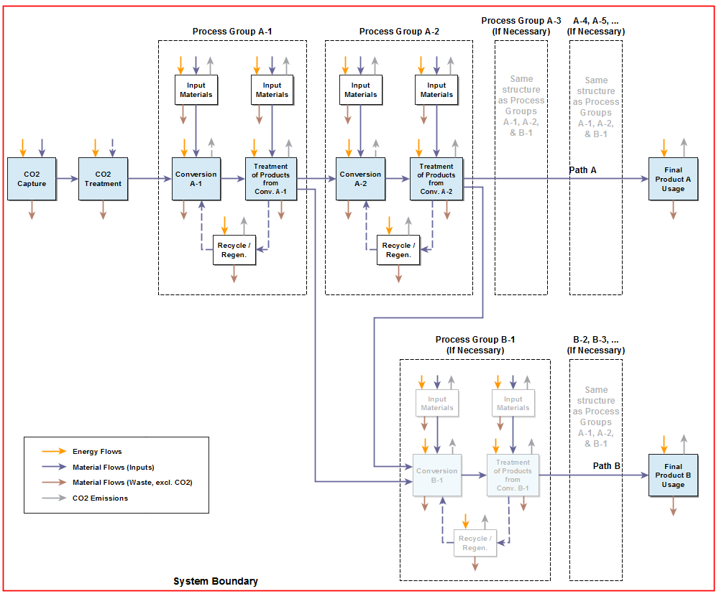

Figure 1. Process diagram showing the system boundary and main flows into and out of the model.

## Caution when Interpreting Results

Note the following cautions when interpreting study results:

1. In Figure 2 (emissions per kg of product), the comparison per kg of product cannot be done with more than one product at a time, since 1 kg of diesel has a different meaning (or function) than 1 kg of methane from an LCA perspective.
2. The incumbent technology estimates are one example of a conventional production method. For consistency, the emission factors selected in the General Assumptions are also applied to the incumbent technologies. Importantly, even though it is possible to change the intensities of inputs for incumbents, the incumbent technology estimates do not cover the full range of possible technologies that the CCU pathways will compete against in the future. Competitors were not considered. This will be expanded in future work.
3. Avoided emissions are the difference between the CCU and the incumbent technology. However, time frame mismatch was not considered, and so avoided emissions estimates need to be interpreted with caution, since the incumbent technology is a currently established technology and the CCU alternative is expected to be deployed in the future.
4. Global Reduction Potential is a high-level estimate given the market size of 2015 and assuming a market penetration of 50%. More sophisticated models were not applied. This will be expanded in future work.
5. The end use phase is considered for fuels to be full combustion. Transportation and distribution of end-products are not included.

## Terms of Use

This is a beta version of the LCA Estimate Model for CCU tool. It is not intended to provide definitive LCA results, instead it provides illustrative LCA examples of CCU pathways.

You accept that the Software is offered to you on an “as is” basis, and neither Dr. Bergerson or the University is making any warranties of any kind regarding its performance, including merchantability, fitness for any purpose or non-infringement.

You understand that you are using this software entirely at your own risk. You agree that neither Dr. Bergerson or the University will be liable for any direct, indirect, special, incidental or consequential damages resulting from your use, misuse or inability to use this software, even if Dr. Bergerson or the University has been advised of the possibility of such damages.

# Guide to the User Interface

The section below presents the interface, how the user can interact with the model, and an overview of the link between worksheets.

## Main Input & Output

The Main Input & Output worksheet (**sheet tab colour: red**), contains all the basic options to run the model for all carbon conversion pathways. The page is divided in two major panels, one on the left (black) and one in the right (red). On the left side of the worksheet, the user can select in the General Assumptions box the source of inputs (electricity, heat, steam, hydrogen, carbon source) for all pathways. Below General Assumptions are boxes for each pathway where the user can modify the assumptions made that are specific to that pathway.

By changing the values of consumption or the intensity (emission factors), the figures on the Results Dashboard on the right, will update automatically. Assumptions for each pathway can be reverted to model defaults by pushing the appropriate Reset Pathway button. To revert all pathway inputs to model defaults, push the Reset All button in the General Assumptions box. A list with acronyms is provided in the Acronyms worksheet.

On the right side of the worksheet is the Results Dashboard, where the user can generate dynamic visualizations of the results. Changing the inputs on the left side of the worksheet will be automatically updated in the Results Dashboard. Results in the dashboard are presented for:

1. Emissions per kg of CO2 converted

* Net emissions per 1 kg of CO2 converted in each pathway
* Metric of evaluation: kg CO2eq/kg CO2 converted

1. Emissions per kg of product

* Net emissions of each pathway per 1 kg of product formed in each pathway
* Metric of evaluation: kg CO2eq/kg product

1. Avoided emissions

* Net emissions of incumbent per kg of product less the net emissions for the pathway per kg of product
* Metric of evaluation: kg CO2eq avoided/kg product

1. Global reduction potential

* Avoided emissions from a pathway multiplied by 50% of the market size of the pathway
* Metric of evaluation: Gt CO2eq

Figure notes are provided in grey boxes to the right of each figure.

### Main Input: General Assumptions

Figure 2 shows the model’s General Assumptions input box. In this box, the user can select from a dropdown list the source of each input (electricity, heat, steam, hydrogen, and carbon source).

Alternatively, users can define their own emission factor for each input. To run the model using a different emission factor, first the user should input a numeric value to the green cell, then check the toggle button on the left to apply that emission factor to the pathways. By unchecking the option, the calculation will use the source defined in the dropdown list.

Inputs can be reset to model defaults by pushing the Reset All button. Checking the “Show additional literature values in Figure 1” toggle button adds literature values for some of the pathways to the display of results in the Results Dashboard.

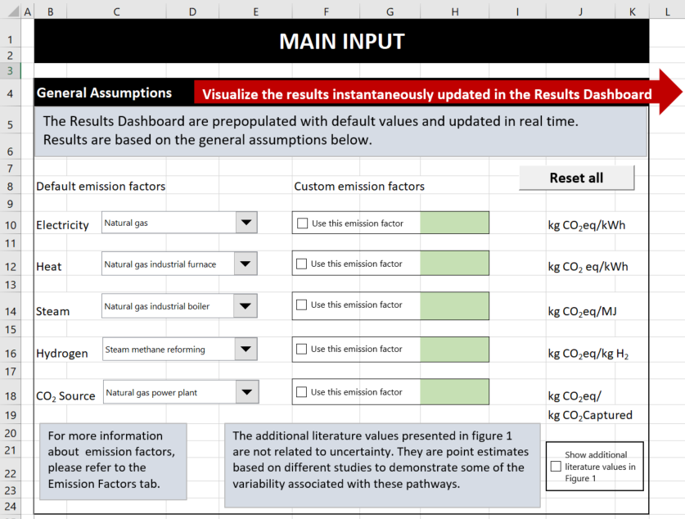

Figure 2. General Assumptions input box

### Main Input: Example Pathway

Figure 3 shows the CO2 Mineralization pathway inputs box. Within each section there is a sub-section for each sub-pathway and product within the larger pathway (e.g., DMC-W sub-pathway with calcite product within the CO2 Mineralization pathway). The default input values (e.g., electricity, heat) required to produce one unit of product are shown in the green cells and can be updated by the user in these cells. The emission factor for each input (emissions from the source of each input) can be selected from the dropdown list next to each input. For example, the user can select natural gas as the source of electricity. The emissions intensity of electricity consumed will then be calculated in the model given the emission factor for electricity sourced from natural gas. To reset pathway inputs to model defaults, the user can click the Reset Pathway button.

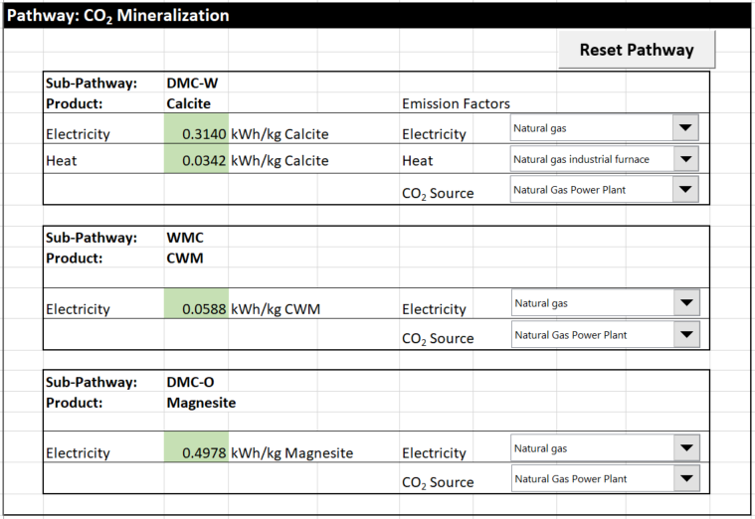

Figure 3. Example inputs box for the CO2 Mineralization pathway.

The numeric default values in the green cells are defined in the Scenario Manager tool (an Excel built-in tool that can be found in menu option Data, and subitem Forecast); thus, users are advised not to modify the options that were previously defined.

### Results Dashboard: Emissions per kg CO2 Converted

Figure 4 shows a set of example results for emissions per kg of CO2 converted. The metric of evaluation of this figure (kg of CO2eq emitted per kg CO2 converted) is the net emissions for each pathway per 1 kg of CO2 converted in each pathway.

This metric is useful to compare different CCU pathways and/or products in terms of CO2 utilization. However, other metrics of comparison such as per kg of product are needed.

Using default settings, the emission factors for all pathways are assumed to be the same and are set in the General Assumptions section, on the left-hand side of the Main Input & Output worksheet. However, the intensity can be changed across all pathways in the General Assumptions section, or for individual pathways in each sub-section below.

The legend entries are related to each life cycle phase:

- CO2 Converted: CO2 that is converted in each pathway. This value is held constant at -1.

- CO2 Capture Process: emissions associated with capturing the CO2 necessary for each pathway.

- Electrolysis: emissions of the electrolysis process for hydrogen production in the CO2 Reduction Involving Electricity pathway.

- CO2 Conversion Process: emissions associated with the CO2 conversion step.

- End Use: emissions related to the use phase of each end product.

- Net: net emissions of each pathway - summation of the emissions of all life cycle phases.

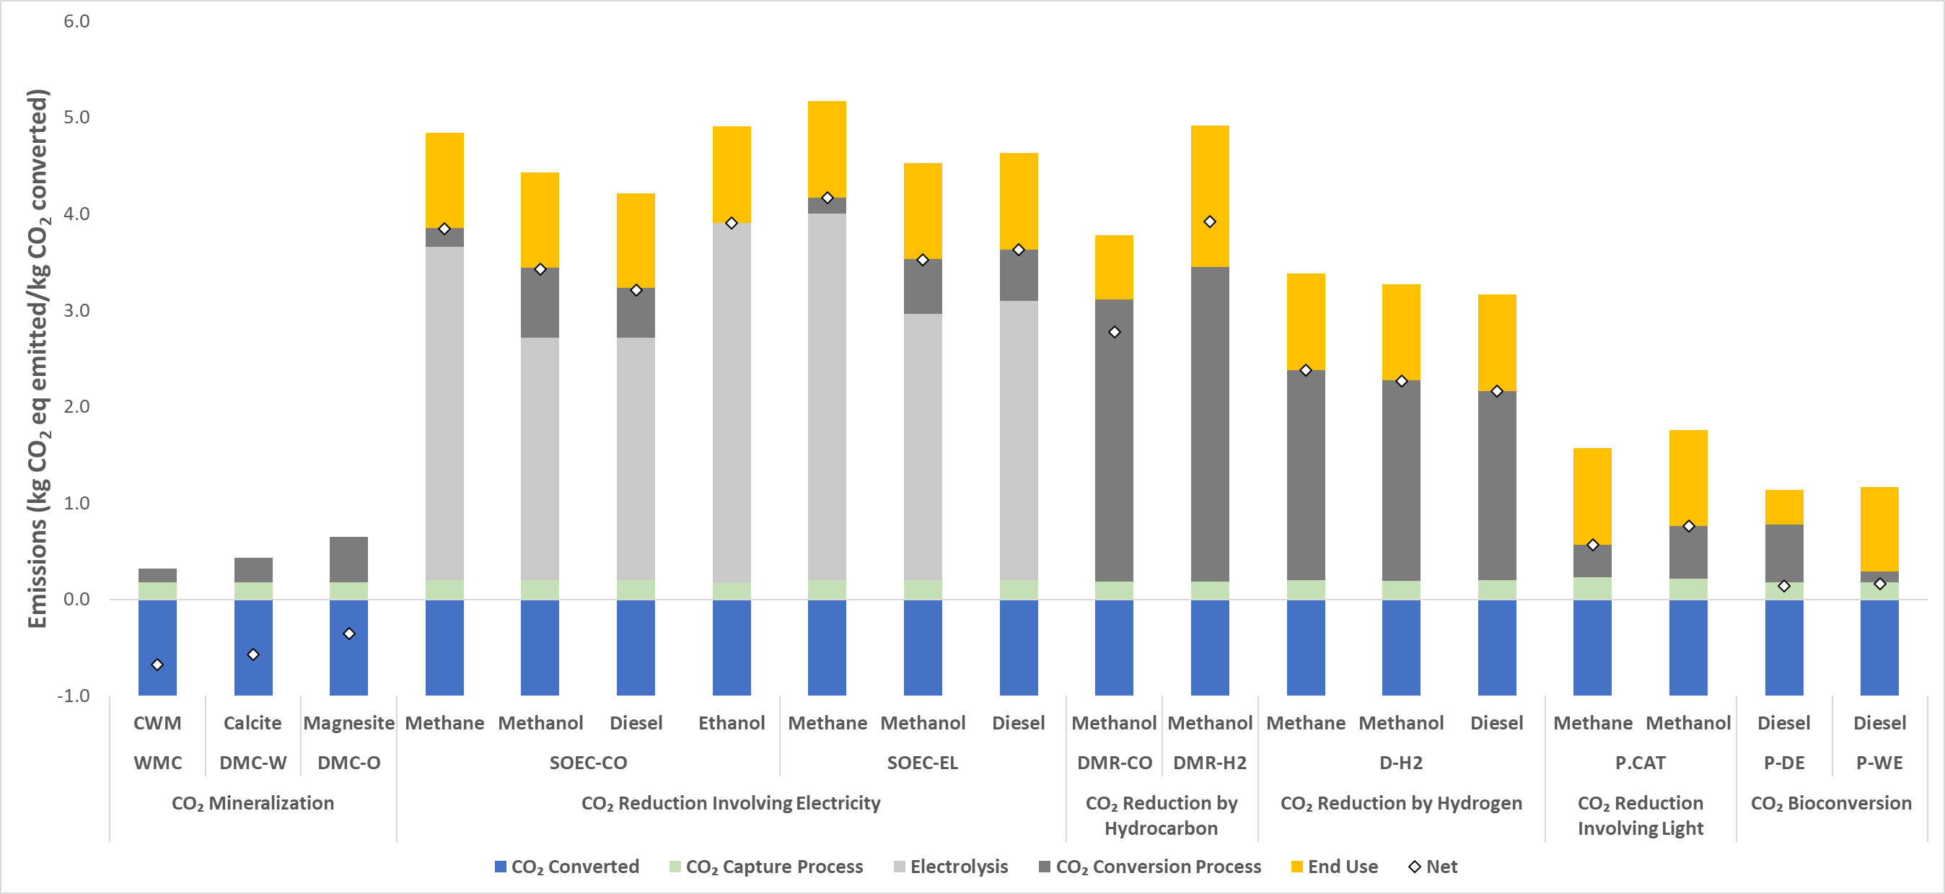

Figure 4. Example results: emissions per kg of CO2 converted.

### Results Dashboard: Emissions per kg of Product

Figure 5 shows a set of example results when the metric of evaluation is emissions per kg of product. This metric is the net kg of CO2 eq emitted per kilogram of product produced by that pathway The product results to display in the Results Dashboard can be selected from the dropdown list at the top of this section.

Comparison across products is not allowed in this section, since for example, 1 kg of magnesite is not equivalent to 1 kg of diesel or methane.

The last column in the figure is the net emissions of the incumbent technology, which is one estimate of a conventional production method. Competitors were not considered.

For consistency, the emission factors defined in the General Assumptions section are applied to the incumbent. Importantly, even though it is possible to change the intensities of inputs for incumbents, the incumbent estimate does not cover the full range of possible technologies that the CCU pathways will compete against in the future.

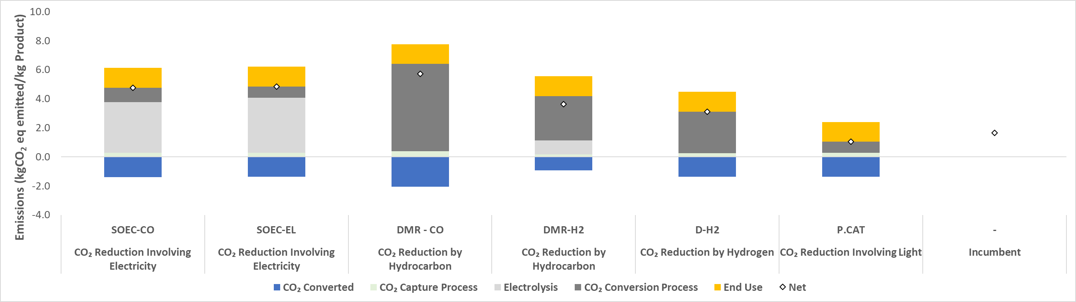

Figure 5. Example results: emissions per kg of product

### Results Dashboard: Avoided Emissions

Figure 6 shows a set of example results for avoided emissions. The metric of evaluation is kg of CO2 eq avoided per kg of product.

CCU pathways are compared to the incumbent technologies. Avoided Emissions are calculated as follows:

Avoided Emissions = [(Net Incumbent GHG per kg of product) - (Net CCU GHG per kg of product)]

Thus, if the Avoided Emissions result is positive, the CCU pathway has lower net emissions than the incumbent technology.

The incumbent technology is one estimate of a conventional production method. Competitors were not considered. For consistency, the emission factors defined in the General Assumptions section are applied to the incumbent. Importantly, even though it is possible to change the intensities of inputs for incumbents, the incumbent technology results in the figure does not cover the full range of possible technologies that the CCU pathways will compete against in the future.

There is also a timeframe mismatch between the incumbent technology emissions results and the timeline for deployment of CCU technologies that was not considered. This result needs to be analyzed with caution (see Cautions When Interpreting Results section).

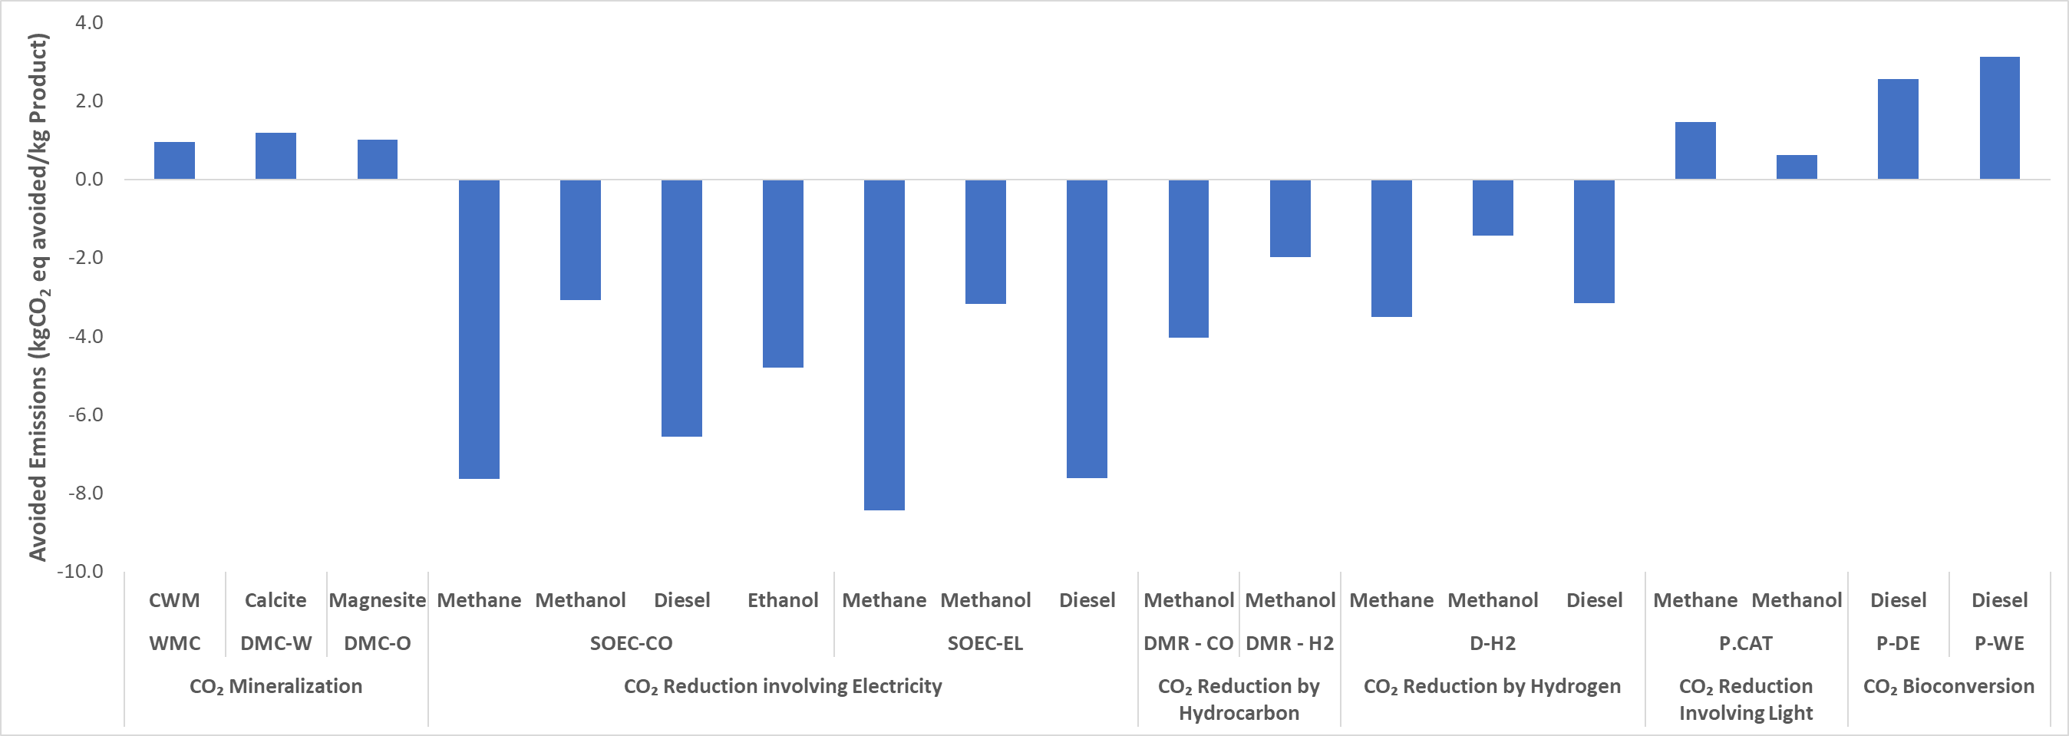

Figure 6. Example results: avoided emissions.

### Results Dashboard: Emissions Reduction Potential

Figure 7 shows a set of example results for emissions reduction potential. The Global Emission Reduction Potential is an estimate of the amount of avoided emissions of a pathway multiplied by the potential market size of the pathway, as follows:

Global Emissions Reduction Potential = [Avoided Emissions per kg product] x [Market Size]

Pathways that do not result in reduction in emissions, are listed as zero.

Market Size values are based on market sizes in 2015. A 50% market penetration was assumed. This is an extremely rough estimate of the potential impact of the pathway in a global scale. Future work will employ more sophisticated modelling to estimate market size.

For mineralization products, Kurad et al. (2017) was used as a reference for the market size. For other products, market sizes are estimated from The Global Roadmap for Implementing CO2 Utilization (ICEF, 2016).

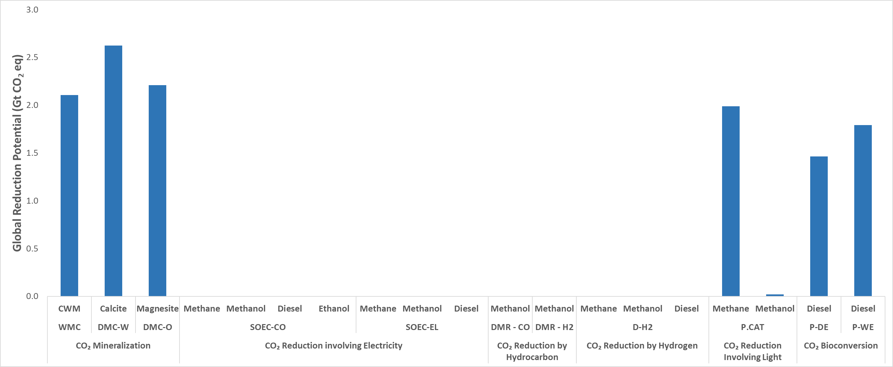

Figure 7. Example results: global emissions reduction potential.

## Summary Table

The Summary Table worksheet (**sheet tab colour: blue**) presents a breakdown of all pathway results for the four metrics of evaluation calculated by the model, with a breakdown by life cycle stage.

This worksheet is used by the figures in the Main Input & Output worksheet as data source and references the cells with the desired results in each individual pathway worksheet. Therefore, users are advised not to insert or delete cells in the spreadsheet, since it may affect this reference and affect the VBA code that runs in the background of the model.

## Individual Pathways

The individual pathway calculation worksheets (**sheet tab colour: blue**) include the following worksheets: Involving Light, Reduction by Hydrogen, Reduction by Hydrocarbon, Involving Electricity, Bioconversion, and Mineralization.

Each of these worksheets display the calculations for the respective pathway. The top section of each worksheet (highlighted in Figure 8) displays the sub-pathway and products currently being represented in the model as well as the emissions intensities (see Active row) and CO2 capture process based on user input on the Main Input & Output worksheet.

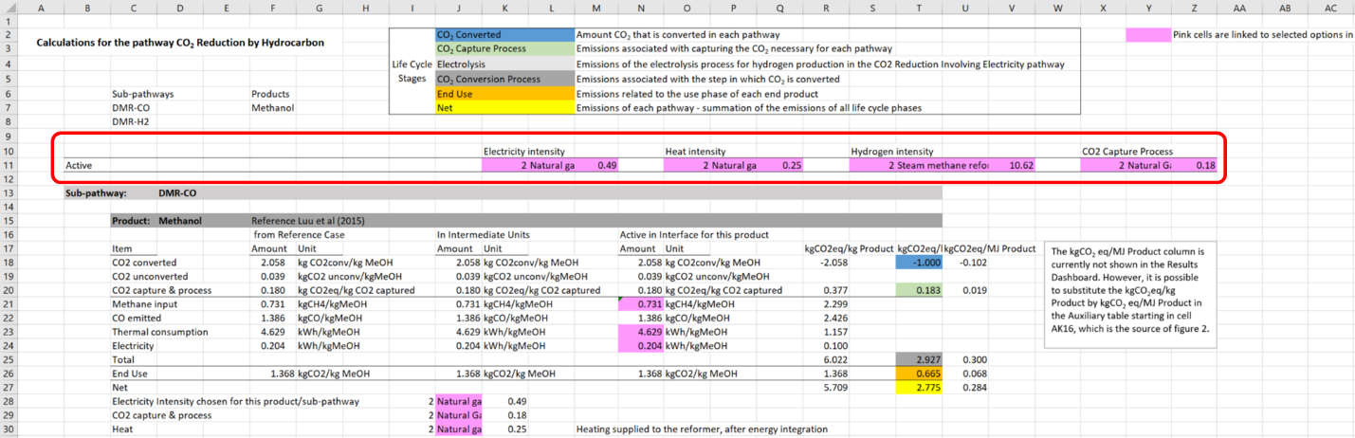

Figure 8: Example of individual pathway tab.

The sections below show the calculations for each sub-pathway and product. The sub-pathway is displayed in the light grey header. Within each sub-pathway section, a dark grey header presents the product for the calculation in the sub-section below that header. The reference used to develop the calculation for this sub-pathway and product is also listed in the dark grey header. Figure 9 highlights the sections used in the calculations.

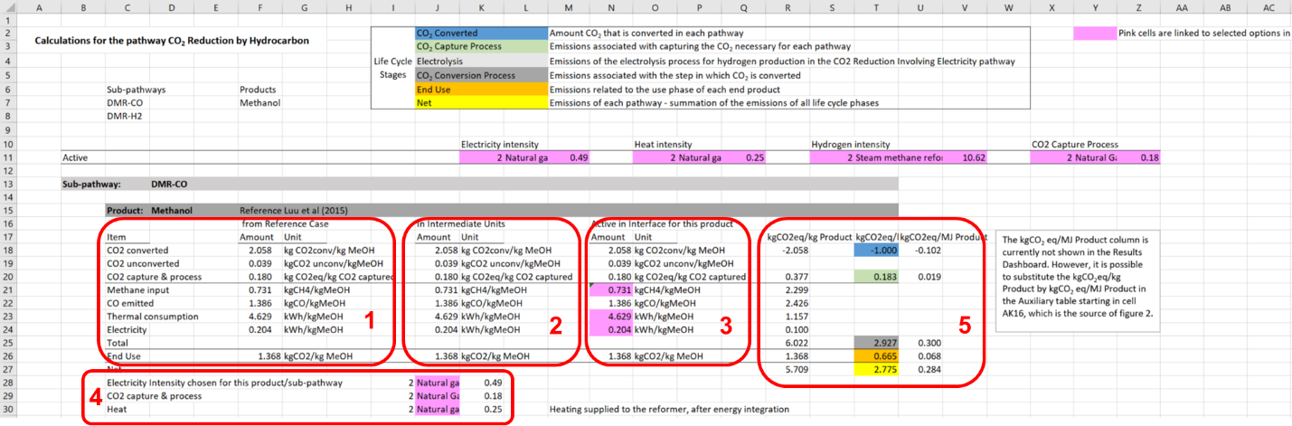

Figure 9: Areas of calculation in each individual pathway tab. Calculation boxes (red) are numbered one through five.

Box 1 of Figure 9 is used mainly to store data from reference studies. When necessary, adjustments were made to reference study data and can be tracked in Part II of the documentation for each pathway. This section may be altered if users prefer to edit the values directly in the calculation worksheets. Box 2 contains data from Box 1, transformed into consistent units. Box 3 contains the data that is active in the interface for the product. Box 4 contains the emission factors active for the specific pathway, linked to the dropdown menus in the Main Input & Output tab. Finally, Box 5 presents the emissions results broken down by life cycle stage for different metrics considered in the model. The metric of kg CO2eq/MJ (in case of fuels) is presented in the calculation worksheet but not used in the Main Input & Output tab. However, in case the user wants to check this metric, it is possible to substitute the kg CO2eq/kg product for kg CO2eq/MJ in the auxiliary table (starting at Column AK of each calculation worksheet), which is where data for Figure 2 (Emissions of kg CO2eq/kg product) in the Main Input & Output worksheet is derived from.

## Incumbents

Each individual pathway worksheet follows the same structure. The Incumbents worksheet is different. Figure 10, Box 1, shows the calculation for each product. The emission factors selected in the General Assumptions section (in Main Input & Output worksheet) are applied for the incumbents. User defined emission factors are also applied in the calculation of incumbents.

Additional comments can be found in Box 2.

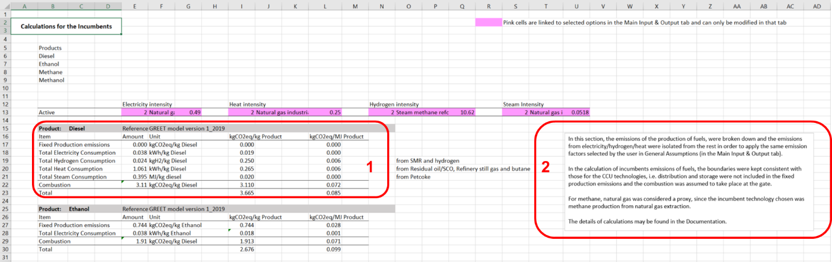

Figure 10: The Incumbents worksheet.

## Energy & Unit Conversions

The Energy & Unit Conversions worksheet (**sheet tab colour: green**) displays on the left side of the worksheet the heating values (lower and higher heating values, with references) employed in the model. The right side of the worksheet displays unit conversions employed in the model.

## Constants

The Constants worksheet (**sheet tab colour: green**) presents the market size (in Gigatons, based on 2015 data) for each product. Products include carbonates, diesel, methane, methanol, and ethanol.

## Process Correlations

The Process Correlations worksheet (**sheet tab colour: green**) displays correlations employed in the model for the following:

* SOEC-CO 🡪 methane
* SOEC-CO 🡪 methanol
* SOEC-CO 🡪 diesel
* PEM 🡪 diesel

## Emission Factors

The Emission Factors worksheet (**sheet tab colour: green**) lists all emission factors employed in the model as well as a few other example emission factors. Figure 11 shows the Emission factors worksheet. The left side of the worksheet presents the emission factors active in the model for different inputs to the CCU process (electricity, and heat in kg CO2eq/kWh, steam in kg CO2eq/MJ, and hydrogen in kg CO2eq/kg hydrogen) as well as emissions from each CO2 capture process (in kg CO2eq/kg CO2 captured). The value of Active in Interface row is related to the option selected in the General Assumptions section. The right side of the worksheet presents the supporting emission factors and GWP values used in the model. The center section of the worksheet presents a few examples of emission factors based on US data.

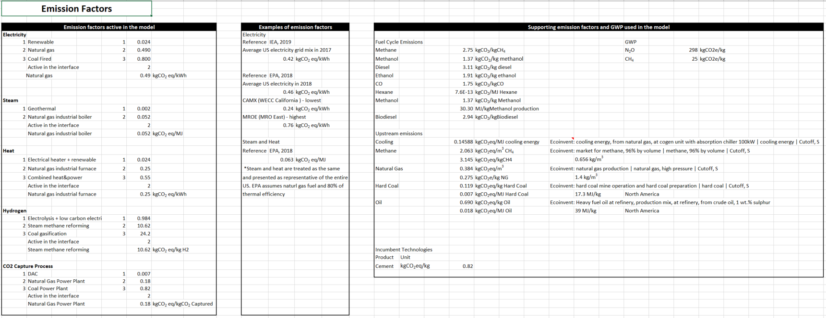

Figure 11: The Emission Factors worksheet.

Table 2 below summarizes the references of each emission factor used in the model.

Table 2: References for emission factors employed in the model.

|  |  |
| --- | --- |
| Parameter | Reference |
| Electricity | Schlömer et al., 2014  GREET model, 2015 |
| Steam | EPA, 1996  Schlömer et al., 2014 |
| Heat | ISCC, 2017  Doluweera et al., 2011  Schlömer et al., 2014 |
| Hydrogen | Spath and Mann, 2001  Mehmeti et al., 2018  Simbeck and Chang, 2002 |
| CO2 Capture Process | Helmeth Consortium, 2017 |

# Part II: Technical Documentation

# Reference Studies

* 1. CO2 Mineralization

For CO2 mineralization, the reference study for direct mineral carbonation of olivine to produce magnesite was selected because it provides a more realistic weight percentage of mineral to rock compared to alternative studies and presents the data in an organized manner in terms of life cycle stages. For the sub-pathway of direct mineral carbonation using wollastonite, the reference case was chosen due to more detailed data, which allowed more sensitivity analyses. For the waste mineral carbonation sub-pathway, the selected study was based on typical operating conditions but with overall lower energy consumption and cost, indicating a higher potential to become a commercial process.

* + 1. DMC-W

Product: **Calcite**

Scenario #1: Giannoulakis, S., Volkart, K., Bauer, C. 2014. Life cycle and cost assessment of mineral carbonation for carbon capture and storage in European power generation. International Journal of Greenhouse Gas Control. DOI: 10.1016/j.ijggc.2013.12.002.

* + 1. DMC-O

Product: **Magnesite**

Scenario #2: Giannoulakis, S., Volkart, K., Bauer, C. 2014. Life cycle and cost assessment of mineral carbonation for carbon capture and storage in European power generation. International Journal of Greenhouse Gas Control. DOI: 10.1016/j.ijggc.2013.12.002.

* + 1. WMC

Product: **CWM**

Pan, S.-Y., Lafuente, A.M.L., and Chiang, P.-C. 2016. Engineering, environmental and economic performance evaluation of high-gravity carbonation process for carbon capture and utilization. Applied Energy, vol. 170, p. 269–277.

* 1. CO2 Bioconversion

For this pathway, representative cases of the wet extraction were selected due to being based on real pilot scale data (since no commercial scale plant was found) and because the system was scaled to represent future plants. For the dry extraction sub-pathway, the system was selected because the it presents potential to be applied in the future.

* + 1. P-DE (Photobioreactor Dry-Extraction)

Product: **Diesel**

Lardon, L., Hélias, A., Sialve, B., Steyer, J.P., Bernard, O. 2009. Life-Cycle Assessment of Biodiesel Production from Microalgae. Environmental Science & Technology. DOI: 10.1021/es900705j.

* + 1. P-WE (Pond Wet Extraction)

Product: **Diesel**

Liu, X., Saydah, B., Eranki, P., Colosi, L.M., Greg, M.B., Rhodes, J., Clarens, A.F. 2013. Pilot-scale data provide enhanced estimates of the life cycle energy and emissions profile of algae biofuels produced via hydrothermal liquefaction. Bioresource Technology. DOI: 10.1016/j.biortech.2013.08.112

* 1. CO2 Reduction Involving Electricity

For this pathway, reference studies were chosen based on the reported energy demand, the studies with demands closer to commercial solutions were selected. In terms of commercialization, SOEC is at a lower readiness level compared to PEM – SOEC is being tested at lab scale while PEM is already being commercialized. For the spreadsheet, PEM was removed from the final chart due to the number of other products and sub-pathways, but the calculations can still be found in the respective tab.

* + 1. SOEC-CO

Product: **Methane, Methanol and Diesel**

Fu, Q., Mabilat, C., Zahid, M., Brisse, A., Gautiner, L. 2009. Syngas production via high-temperature steam/CO2 co-electrolysis: an economic assessment. Energy & Environmental Science. DOI: 10.1039/c0ee00092b

Product: **Ethanol**

Spurgeon, J.M., Kumar, B. 2018. A comparative technoeconomic analysis of pathways for commercial electrochemical CO2 reduction to liquid products. Energy & Environmental Science. DOI: 10.1039/c8ee00097b.

* + 1. SOEC-EL

Product: **Methane and Methanol**

Hoppe, W., Thonemann, N., Bringezu, S. 2017. Life Cycle Assessment of Carbon Dioxide–Based Production of Methane and Methanol and Derived Polymers. Journal of Industrial Ecology. DOI: 10.1111/jiec.12583

Product: **Diesel**

van der Giesen, C., Kleijn, R., Kramer, G. J. 2014. Energy and Climate Impacts of Producing Synthetic Hydrocarbon Fuels from CO2. Environmental Science & Technology. DOI:10.1021/es500191g

* 1. CO2 Reduction by a Hydrocarbon
     1. DMR-CO

Product: **Methanol**

Luu, M. Milani, D., Bahadori, A., Abbas, A. 2015. A comparative study of CO2 utilization in methanol synthesis with various syngas production technologies. Journal of CO2 Utilization. DOI: 10.1016/j.jcou.2015.07.001.

* + 1. DMR-H2

Product: **Methanol**

Luu, M. Milani, D., Bahadori, A., Abbas, A. 2015. A comparative study of CO2 utilization in methanol synthesis with various syngas production technologies. Journal of CO2 Utilization. DOI: 10.1016/j.jcou.2015.07.001.

* 1. CO2 Reduction by Hydrogen
     1. D-H2

Product: **Diesel**

van der Giesen, C., Kleijn, R., Kramer, G. J. 2014. Energy and Climate Impacts of Producing Synthetic Hydrocarbon Fuels from CO2. Environmental Science & Technology. DOI:10.1021/es500191g

Product: **Methane**

Hoppe, W., Thonemann, N., Bringezu, S. 2017. Life Cycle Assessment of Carbon Dioxide–Based Production of Methane and Methanol and Derived Polymers. Journal of Industrial Ecology. DOI: 10.1111/jiec.12583

Product: **Methanol**

Perez-Fortes, M., Schöneberger, J.C., Boulamanti, A., Tzimas, A. 2016. Methanol synthesis using captured CO2 as raw material: Techno-economic and environmental assessment. Applied Energy. DOI: 10.1016/j.apenergy.2015.07.067

* 1. CO2 Reduction Involving Light

For this pathway, the reference study selected provided a good level of detail of the fuel production process.

* + 1. P.CAT

Product: **Methane and Methanol**

Trudewind, C.A., Schreiber, A., Haumann, D. 2014. Photocatalytic methanol and methane production using captured CO2 from coal-fired power plants. Part I - a Life Cycle Assessment. Journal of Cleaner Production. DOI: 10.1016/j.jclepro.2014.02.014

* 1. Incumbent Technologies

For the incumbent technologies, GREET model was used.

Product: **Diesel, Ethanol, Methane and Methanol**

Argonne National Laboratory (ANL). 2019. GREET 1_2019 Available at: <https://greet.es.anl.gov/greet_1_series>.

# Pathway: CO2 Mineralization

For mineralization pathway, the data found in reference studies did not need to be manipulated. Thus, detailed and additional calculation is not needed.

# Pathway: CO2 Reduction Involving Electricity

* 1. SOEC-CO

For this sub-pathway, the first step is the production of syngas by co-electrolysis of steam and carbon dioxide, followed by a secondary conversion leading to methane, methanol or diesel. Syngas is not presented in the main page since it is an intermediary product, but the calculations are shown in the pathway tab.

For the syngas production stage, the mass and energy balance presented in Table 2 of the reference study (Fu et al., 2009) was used, and the amount of CO2 needed was calculated by:

The CO2 unconverted was calculated the same way, resulting in 0.16 kg CO2 unconverted/kg syngas.

The electricity needed for co-electrolysis was calculated by:

Applying the emission factor for electricity based on natural gas:

For heating emissions:

In this stage, the unconverted CO2 (0.15 kgCO2/kg syngas) is also added. Thus:

For methane production, syngas is reacted with extra H2 in a methanation step. For each kg of methane produced, 2 kg of syngas are needed. Thus,

For the extra H2 production, a commercially available electrolyser was assumed (Sunfire company, Germany) with an electricity demand of 41 kWh/kg H2 produced.

For heating:

For the methanation step, two options exist (Rönsch et al., 2016): CO methanation (CH4 production from carbon monoxide) and CO2 methanation (CH4 production from carbon dioxide). It was assumed that electricity demand for both types of catalytic methanation are the same and equals to 0.335 kWh/kg CH4 (Hoppe et al., 2017).

In the end use phase, emissions are from the combustion of methane with 100% conversion. Thus:

For methanol production, 1 kg of syngas is needed per kg of methanol. Therefore, most of calculation is the same as the one presented for syngas.

In this case, the methanol synthesis stage has an electricity demand of 1.27 kWh/kg methanol (Hoppe et al., 2017).

For diesel production, 2.3 kg of syngas are needed per kg of diesel (van der Giesen et al., 2014). In this case, data from Fu et al. (2009) was used for syngas production and for Fischer-Tropsch process, van der Giesen et al (2014) was used.

The emission related to the secondary conversion is 1.3 kg CO2eq/kg diesel based on the emission factor of 0.03 kg CO2eq/MJ diesel from van der Giesen et al. (2014).

* 1. SOEC-EL

For methane production, Hoppe et al. (2017) reported CO2 consumption of 2.75 kg CO2/kg methane in Table S1. Applying a 90% CO2 conversion efficiency, the unconverted CO2 was calculated to be 0.31 kg CO2/kg methane.

The hydrogen requirement reported was 0.52 kg H2/kg methane. To generate the hydrogen, a commercially available electrolyser was considered (Sunfire Hylink, 2018) with an electricity demand of 41 kWh/kg H2 produced.

The electricity consumption stated in the reference study for methane production was 0.335 kWh/kg methane. The use phase assumed 100% combustion of the methane, emitting 2.75 kg CO2/kg methane.

For methanol production, Hoppe et al. (2017) reported CO2 consumption of 1.37 kgCO2/kg methanol, consuming 0.19 kg H2/kg methanol and 1.27 kWh/kg methanol of electricity consumption in Table S1.

CO2 conversion of 90% is assumed, resulting in emissions of 0.15 kg CO2/kg methanol. Hydrogen generation is assumed to be by a commercially available electrolyser (Sunfire Hylink, 2018) with an electricity demand of 41 kWh/kg H2 produced. The end use assumed 100% efficiency methanol combustion.

For diesel production, the reference study mentioned 0.07 kg CO2 converted/ MJ diesel, considering 90% CO2 conversion, CO2 unconverted is 0.01 kg CO2/MJ diesel (Figure 4 of the reference study). The 0.07 kg CO2/MJ diesel would result in a slightly different number from the stoichiometry (mass of CO2 needed to synthetize diesel, according to the reaction). Thus, in this case, the stoichiometry value was used to compute the amount of CO2 converted per kg of diesel produced (i.e. 3.11 kg CO2/kg diesel).

The generation of hydrogen reported in the reference study consumed 2 MJ electricity/MJ diesel.

The emission related to the secondary conversion is 1.3 kg CO2eq/kg diesel based on the emission factor of 0.03 kg CO2eq/MJ diesel from van der Giesen et al. (2014).

The PEM sub-category calculations are similar to those for SOEC-EL with the difference that for the electrolysis for hydrogen production, the energy consumption is 54.73 kWh/kg H2 (Hoppe et al., 2017). Calculated values can be found in the spreadsheet; however, the results were not included in the final figures due to the similarity to SOEC-EL sub-pathway.

# Pathway: CO2 Reduction by a Hydrocarbon

* 1. DMR-CO

Data from Table 9 of the reference study (Luu et al., 2015), related to Scenario 1 (CO purging), was used. The data is on a per hour basis, so the results for per kg MeOH were calculated by dividing the inputs by 126.8 tonne/h of methanol produced, and the results are listed in the Table 3 below.

Table 3: Calculated results on per tonne methanol produced basis.

|  |  |  |
| --- | --- | --- |
|  | Unit | Per tonne MeOH |
| CH4 feed | Tonne CH4 | 0.73 |
| CO2 feed | Tonne CO2 | 2.10 |
| Methanol produced | Tonne MeOH | 1.00 |
| CO2 vented | Tonne CO2 | 0.04 |
| Removed CO | Tonne CO | 1.39 |
| Thermal Duty | GJ | 16.66 |
| Electrical duty | GJ | 0.73 |

The CO2 converted was obtained by subtracting the feed CO2 by the CO2 vented, resulting in 2.06 kg CO2/kg MeOH. The CO2 converted is related to the carbon dioxide that produced methanol and to the carbon monoxide that was vented.

The thermal and electrical duty were recalculated to give in units of kWh/kg MeOH:

In this case, since the CO2 vented was explicitly mentioned, the unconverted CO2 was considered as the CO2 vented.

* 1. DMR-H2

Data from Table 10 from the reference study (Luu et al., 2015), related to Scenario 2 (addition of external H2), was used. The data is on a per hour basis, so the results for per kg MeOH were calculated by dividing the inputs by 126.8 tonne/h of methanol produced, and the results are listed in the Table 4.

The CO2 converted was obtained by subtracting the feed CO2 by the CO2 vented, resulting in 0.93 kgCO2/kg MeOH.

The thermal and electrical duty were recalculated to give in units of kWh/kg MeOH:

Table 4: Calculated results on per tonne methanol produced basis.

|  |  |  |
| --- | --- | --- |
|  | Unit | Per tonne MeOH |
| CH4 feed | Tonne CH4 | 0.33 |
| CO2 feed | Tonne CO2 | 0.95 |
| H2 feed | Tonne H2 | 0.09 |
| Methanol produced | Tonne MeOH | 1.00 |
| CO2 vented | Tonne CO2 | 0.02 |
| Thermal Duty | GJ | 12.35 |
| Electrical duty | GJ | 1.05 |

# Pathway: CO2 Reduction by Hydrogen

For diesel production, 2.3 kg of syngas is needed to produce 1 kg of the fuel, while 1.57 kg of CO2 and 0.07 kg of H2 are needed to produce 1 kg of CO (from page 7114 of the reference study). Thus:

Considering 90% CO2 conversion:

For hydrogen, there are two points for demand (CO and diesel production). Syngas has a molar H2:CO ratio of 2:1; thus, in mass basis, there is 0.88 kg CO and 0.13 kg H2 per kg syngas.

For methane production, the study from Hoppe et al. (2017) reported the CO2 consumption of 2.75 kg CO2/kg methane in Table S1 (in reference study). Applying 90% CO2 conversion efficiency, the unconverted CO2 was calculated to be 0.31 kg CO2/kg methane.

The hydrogen amount reported was 0.52 kg H2/kg methane; however, unlike the electrochemical pathway (SOEC-EL), different sources of hydrogen were considered.

The electricity consumption stated in the reference study was 0.335 kWh/kg methane, and the use phase was considered to be the 100% combustion of methane, emitting 2.75 kg CO2/kg methane.

For methanol production, Table 1 from the reference study (Perez-Fortes et al., 2016) was used. The CO2 conversion efficiency of the process is 93.85%, thus the CO2 converted is 1.37 kg CO2/kg MeOH (1.46 kg CO2/kg MeOH*0.9385), and the unconverted CO2 is the remaining (0.09 kg CO2/kg MeOH).

The cooling emission factor was obtained from Ecoinvent, dataset cooling energy, from natural gas, at cogen unit with absorption chiller 100kW | cooling energy | Cutoff, S. The emission factor considered is 0.15 kg CO2eq/MJ cooling energy.

# Pathway: CO2 Reduction Involving Light

For methane production, in the reference study (Trudewind et al., 2014) carbon dioxide is captured from a coal power plant, transported to a photocatalysis plant, separated, transported and stored. To keep the boundaries consistent with the other pathways, the reference study was used to calculate the emissions related to photocatalysis and separation.

Since the inputs and outputs were not on the same basis, some conversions were necessary. The calculations started from the last to the first unit process: separation (Methanol distillation or methane drying), photocatalysis reaction, water desalination. For separation process (methane drying), the final output is 14.3 MJ of methane and the input is 14.5 MJ of methane; thus, the previous processes were adjusted to this input.

The previous process is the photocatalytic conversion and data can be found in Table 6 of the reference study. In this step, the CO2 input is 1 kg and desalinated water input is 0.82 kg per 14.3 MJ of methane produced. Proportionally, for 14.5 MJ of methane output, the inputs were multiplied by 14.5/14.3 (1.01), resulting in 1.01 kg CO2 and 0.83 kg of desalinated water as the inputs.

In the process, desalinated water is provided from a desalination plant. This is not the case everywhere, but this assumption was maintained. Table 5 from the reference study reports the inventory for desalination process. The electricity demand for producing 1000 kg of desalinated water is 8.68 MJ (2.41 kWh); thus, for 0.83 kg of desalinated water, 2.00x10-3 kWh is used.

After the inputs and outputs of all steps were normalized to produce 14.3 MJ of methane, units were converted and values proportional for 1 kg of methane as output were calculated. Table 5 below summarizes the results.

Table 5: Calculated results per kg methane produced.

|  |  |  |
| --- | --- | --- |
| Inputs | unit |  |
| CO2 Captured | kg | 3.55 |
| Oil | MJ | 2.31x10-3 |
| Hard Coal | MJ | 5.24x10-3 |
| Natural Gas | kg | 7.42x10-5 |
| Electricity | kWh | 6.90x10-3 |
|  |  |  |
| Outputs |  |  |
| Methane | kg | 1.00 |
| CO2 emitted | kg | 0.02 |
| CH4 emitted | kg | 2.55x10-5 |

The same process was done for inputs that are not related to energy or direct emissions. Table 6 summarizes the results for these flows.

Table 6: Calculated emissions of additional inputs on per kg methane produced basis.

|  |  |  |  |  |  |
| --- | --- | --- | --- | --- | --- |
| Input | unit | Input per kg  CH4 produced | Emission  Factora | Unit | Emissions (kg CO2eq/kg CH4) |
| Concrete | m3 | 3.55x10-4 | 281.10 | kg CO2eq/m3 | 9.97x10-2 |
| Inorganic chemicals | kg | 2.66x10-5 | 2.11 | kg CO2eq/kg | 5.62x10-5 |
| Iron ore | kg | 5.32x10-6 | 0.03 | kg CO2eq/kg | 1.55x10-7 |
| Transport, lorry >16t | t.km | 6.81x10-3 | 0.17 | kg CO2eq/t.km | 1.15x10-3 |
| Limestone | kg | 1.15x10-4 | 4.00x10-3 | kg CO2eq/kg | 4.45x10-7 |
| Sodium Chloride | kg | 3.85x10-5 | 0.15 | kg CO2eq/kg | 5.81x10-6 |
| Raw Gravel | kg | 9.79x10-4 | 0.01 | kg CO2eq/kg | 1.06x10-5 |
| Clay | kg | 4.20x10-5 | 0.01 | kg CO2eq/kg | 4.32x10-7 |
| Total emissions |  |  |  |  | **1.01x10-1** |

aEmission factors were obtained from the Ecoinvent database (Wernet et al., 2016).

The CO2 conversion reaction to methane requires 1 mole of CO2 to produce 1 mole of methane; 2.75 kg CO2 is converted per kg of methane. Since no other useful product is mentioned, the stoichiometry was used and the difference was considered as unconverted CO2, resulting in 0.80 kg CO2.

For methanol production, the same reference study was used, and the calculations follow the same structure as for methane.

# Incumbent Technologies

For the calculation of emissions from incumbent technologies, data from GREET 1_2019 (ANL, 2019) was adjusted to maintain consistency with the boundaries considered for the CCU technologies. Thus, emissions and inputs from distribution and storage phases were not included.

In the GREET model, the greenhouse gases considered in the calculation were those with global warming potentials defined in the Fuel_Specs worksheet: CO2, N2O, CH4, NOx, BC, OC and VOC.

Product: **Diesel**

Data for diesel production was obtained from the Excel version of GREET 1_2019. The default options were maintained.

The following assumptions were made regarding the inputs for diesel production (based on Table 2 – Shares of Combustion Processes for each stage):

Table 7: Assumptions for diesel production.

|  |  |  |
| --- | --- | --- |
| Input from GREET | Btu/mmBtu diesel | Assumption |
| Residual Oil | 31057.67 | Used to produce heat |
| Natural Gas | 51881.78 | Used in Steam Methane Reforming |
| Petcoke | 9233.46 | Used to generate steam |
| Butane | 99.16 | Used to generate heat |
| Refinery Still Gas | 58068.50 | Used to generate heat |

The total electricity and hydrogen requirements are 3212.86 Btu electricity/mmBtu diesel and 12910.95 Btu Hydrogen/mmBtu diesel, respectively. Heat requirements were determined by taking the sum of the inputs for residual oil, butane and refinery still gas. For hydrogen, the inputs for natural gas and hydrogen were summed. Applying unit conversion factors and fuels properties from the Fuel_Specs worksheet in GREET 1_2019 (LHV and density), the requirements were calculated as shown in Table 8.

Table 8: Calculated requirements for diesel production.

|  |  |
| --- | --- |
| Heat | 1.06 kWh/kg diesel |
| Hydrogen | 0.02 kg H2/kg diesel |
| Electricity | 0.04 kWh/kg diesel |
| Steam | 0.40 MJ/kg diesel |

Fixed emissions are the emissions remaining after the deduction of emissions related to the inputs mentioned previously (e.g., natural gas, heat, etc). Greenhouse gases emissions from GREET 1_2019 (information provided below) were used, with global warming potentials from GREET’s Fuel_Specs worksheet. The resultant emissions in kg CO2eq/kg diesel were 1.44x10-4 kg CO2eq/kg diesel. In the LCA of CCU estimate model, combustion emissions were added to the fixed and utilities emissions.

* Tab in GREET Excel model: Petroleum
* Table: 3) Calculations of Energy Consumption, Water Consumption, and Emissions for Petroleum Fuels By Stage
* Column: Conventional Diesel
* Stages: Conv. Diesel Refining: Feed Inputs, Conv. Diesel Refining: Intermediate Product Combustion, and Conv. Diesel Refining: Non-Combustion Emissions. The remaining two columns were not considered (Conv. Diesel Transportation and Distribution, Conv. Diesel Storage)

Product: **Ethanol**

Data was obtained from Excel version of GREET model:

* Tab in GREET model: EtOH
* Table: 4.1) Energy Consumption, Water Consumption, and Total Emissions
* Column: Corn Ethanol: Combined Dry and Wet Milling Ethanol – Ethanol (Column J)
* Dry Mill Ethanol Production with and without Corn Oil Extraction, Dry Mill Ethanol Production with and without Corn Oil Extraction: Non-Combustion Emissions, Dry Mill Ethanol Production with and without Corn Oil Extraction: Energy and Emission Credits of Co-Generated Electricity, Wet Mill Ethanol Production, Wet Mill Ethanol Production: Non-Combustion Emissions and Dry Mill Ethanol Production: Energy and Emission Credits of Co-Generated Electricity were included.

The Combined Dry and Wet Milling ethanol case was selected since in the US, both processes produce ethanol. Total electricity requirement is 0.04 kWh/kg ethanol and fixed emissions are 0.74 kg CO2eq/kg ethanol.

Product: **Methane**

Data was obtained from Excel version of GREET 1_2019 model:

* Tab in GREET model: NG
* Table: 3) Calculations of Energy Consumption, Water Consumption, and Emissions for Each Stage
* Columns: Conventional NG/Shale Gas Recovery, Conventional NG/Shale Gas Processing, Conventional NG/Shale Gas Processing: Non-Combustion Emissions

Natural gas extraction was selected as source of methane due to its commercial application. It is important to emphasize that the final purification of natural gas was not included in the calculations. Regarding the share of each type of gas, it was considered that 48% is from conventional natural gas and 52% from shale gas.

The fixed emissions are related to the natural gas flaring, resulting in 0.04 kg CO2eq/kg methane.

The assumptions shown in Table 9 were made regarding the inputs for methane production (based on Table 2 – Shares of Combustion processes for each stage).

Table 9: Assumptions for methane production

|  |  |  |
| --- | --- | --- |
| Input from GREET | Btu/mmBtu diesel | Assumption |
| Residual Oil | 256.00 (Conventional)  243.67 (Shale) | 100% to produce steam |
| Diesel | 3088.16 (Conventional)  2952.44 (Shale) | 33% to produce steam and 67% to produce electricity |
| Gasoline | 256.00 (Conventional)  243.67 (Shale) | 100% to produce electricity |
| Natural gas  (process fuel) | 48139.43 (Conventional)  47078.37 (Shale) | 50% to produce electricity and 50% to produce steam |

The total electricity and steam requirements are 27350.78 Btu electricity/mmBtu methane and 24819.59 Btu Steam/mmBtu methane, respectively. For electricity, the inputs for diesel, gasoline, natural and electricity were summed; and for steam, the inputs for residual oil, diesel and natural gas were summed. Applying unit conversion factors and fuels properties from the Fuel_Specs worksheet in GREET 1_2019 (LHV and density), the requirements were calculated as:

Table 10: Requirements for methane production.

|  |  |
| --- | --- |
| Electricity | 0.36 kWh/kg methane |
| Steam | 1.17 MJ/kg methane |

Product: **Methanol**

Data was obtained from Excel version of GREET 1_2019 model:

* Tab in GREET model: MeOH_FTD
* Table: 3) Calculations of Energy Consumption, Water Consumption, and Emissions for Each Stage
* Column: Natural gas to Methanol

Fixed emissions from natural gas feed loss were calculated as 9204.10 g CO2 eq/mmBtu methanol. After unit conversions, it resulted in 0.18 kg CO2eq/kg methanol.

The natural gas input as process fuel was used for steam production, resulting in 13.72 MJ/mmBtu methanol. Electricity demand was 39500.00 Btu/mmBtu methanol. Applying unit conversion factors and fuels properties from Fuel_Specs tab in GREET 1_2019(LHV and density), the requirements were calculated as:

Table 11: Requirements for methanol production.

|  |  |
| --- | --- |
| Electricity | 0.22 kWh/kg methanol |
| Steam | 0.26 MJ/kg methanol |

# Additional References

Doluweera, G. H., Jordaan, S. M., Moore, M. C., Keith, D. W. and Bergerson, J. A. 2011. "Evaluating the role of cogeneration for carbon management in Alberta," Energy Policy, vol. 39, no. 12, pp. 7963-7974.

EPA, "1.4 Natural Gas Combustion," October 1996. [Online]. Available: https://www3.epa.gov/ttn/chief/old/ap42/ch01/s04/final/c01s04_oct1996.pdf. [Accessed 2018].

GREET, "Distributed - Alberta Mix; Main Output: Electricity," Argonne National Laboratory, 2015. Available at: <greet.es.anl.gov>

Helmeth Consortium, "Helmeth Deliverable 5.2: Final LCA Report," EU, 2017.

ICEF, "Global Roadmap for Implementing CO2 Utilization. CO2 Sciences and The Global CO2 Initiative. Innovation for Cool Earth Forum," 2016.

ISCC, "ISCC PLUS 205-01 GHG Emission Requirements," International Sustainability & Carbon Certification, 2017.

Kurad, R., Silvestre, J. D., Brito, J., Ahmed, H. 2017. “Effect of incorporation of high volume of recycled concrete aggregates and fly ash on the strength and global warming potential of concrete”, Journal of Cleaner Production, vol. 166, pp. 485-502.

Mehmeti, A., Angelis-Dimakis, A., Arampatzis, G., McPhail, S. J. and Ulgiati, S. 2018. "Life Cycle Assessment and Water Footprint of Hydrogen Production Methods: From Conventional to Emerging Technologies," Environments, vol. 5, no. 24, pp. 1-19.

Rönsch, S., Schneider, J., Matthischke, S., Schlüter, M., Götz, M., Lefebvre, J., Prabhakaran, P., Bajohr, S. 2016. “Review on methanation – From fundamentals to current projects,” Fuel, vol. 166, pp. 276-296.

Schlömer, S., Bruckner, T., Fulton, L., Hertwich, E., McKinnon, A., Perczyk, D., Roy, J., Schaeffer, R., Sims, R., Smith, P and Wiser, R. 2014. "Annex III: Technology-specific cost and performance parameters. In: Climate Change 2014: Mitigation of Climate Change. Contribution of Working Group III to the Fifth Assessment Report of the Intergovernmental Panel on Climate Change," Cambridge University Press, Cambridge.

Simbeck, D. R. and Chang, E. 2002. "Hydrogen Supply: Cost Estimate for Hydrogen Pathways – Scoping Analysis," National Renewable Energy Laboratory, Colorado.

Spath, P. L. and Mann, M. K. 2001. "Life Cycle Assessment of Hydrogen Production via Natural Gas Steam Reforming," National Renewable Energy Laboratory, Colorado.

Sunfire Hylink: Low-Cost Hydrogen Production - Sunfire. (2018). Available at: https://www.sunfire.de/en/products-and-technology/sunfire-hylink. (Accessed: 16th August 2018)

Wernet, G., Bauer, C., Steubing, B., Reinhard, J., Moreno-Ruiz, E., and Weidema, B., 2016. “The ecoinvent database version 3 (part I): overview and methodology”, The International Journal of Life Cycle Assessment, 21(9), pp.1218–1230. Available at: <http://link.springer.com/10.1007/s11367-016-1087-8>